***Data Transforming using Snowflake Sql***

* *Creating a duplicate table for data transforming and to do reports*

create table agri as

select * from bi_dataset;

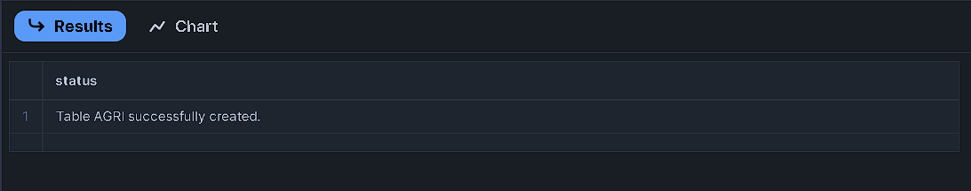**RESULTS:**

select * from agri;

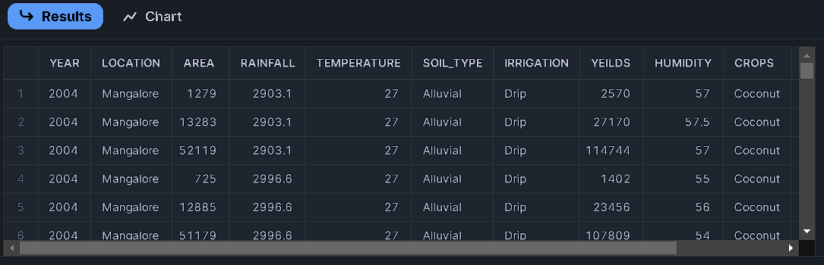**RESULTS:**

update agri

set rainfall = 1.1*rainfall;

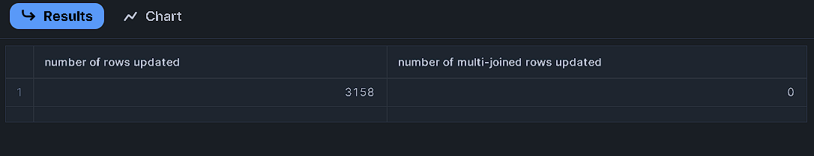**RESULTS:**

update agriculture

set area = 0.9*area;

**RESULTS:**

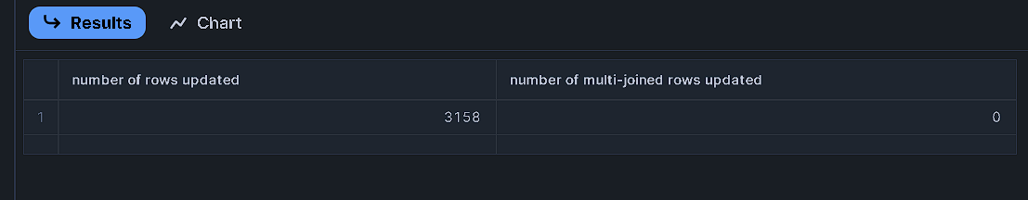

select * from agri;

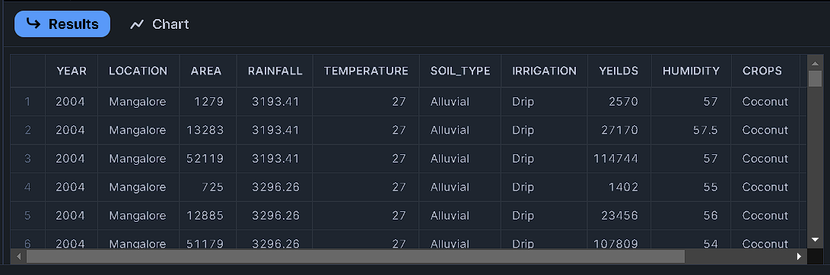**RESULTS:**

//for grouping years

//Year 2004 & 2009 - Y1, Year 2010 & 2015 - Y2, Year 2016 & 2019 - Y3

ALTER TABLE Agri

add Year_Group String;

**RESULTS:**

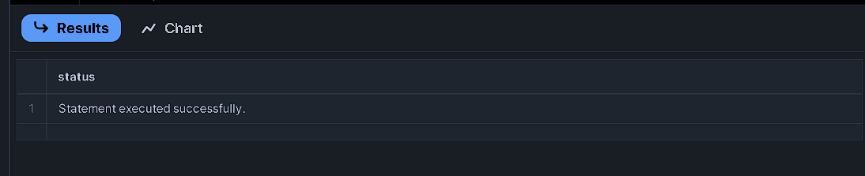

//1st update

update agri

set year_group = 'Y1'

where year >=2004 and year<=2009

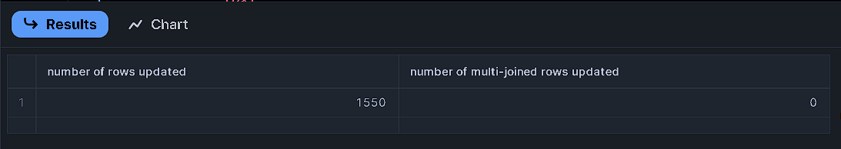**RESULTS:**

//2nd update

update agri

set year_group = 'Y2'

where year >=2010 and year<=2015

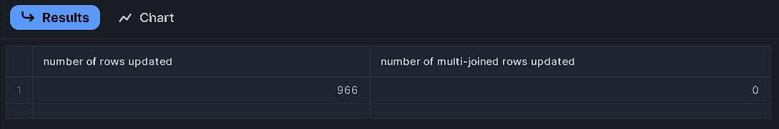**RESULTS:**

//3rd Update

update agri

set year_group = 'Y3'

where year >=2016 and year<=2019

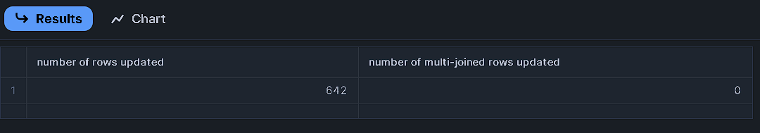**RESULTS:**

select * from agri;

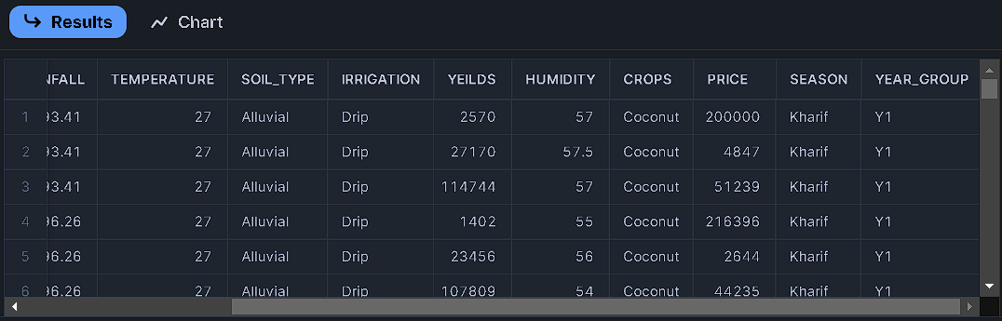**RESULTS:**

//for grouping Rainfall

//Rainfall_Groups

//Min 255 Max 4103

//rainfall 255 & 1200 - Low

//rainfall 1200 2800 - Medium

//Rainfall 2800 & 4103 - High

alter table agri

add rainfall_groups string;

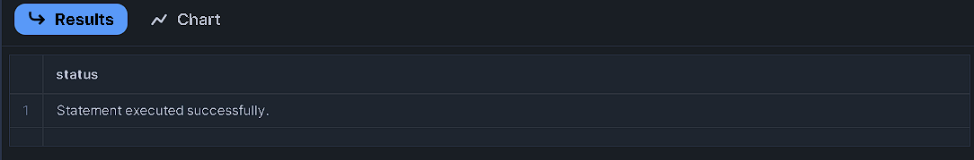**RESULTS:**

//1st Update

update agri

set rainfall_groups = 'Low'

where rainfall>=255 and rainfall<1200

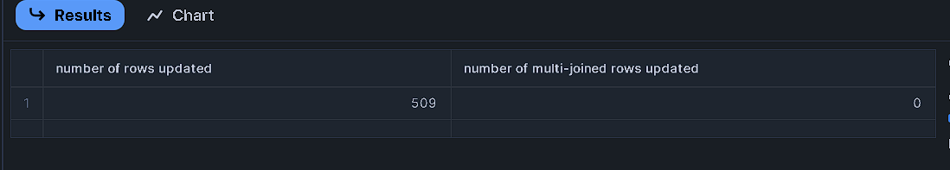**RESULTS:**

//2nd update

update agri

set rainfall_groups = 'Medium'

where rainfall >=1200 and rainfall<2800

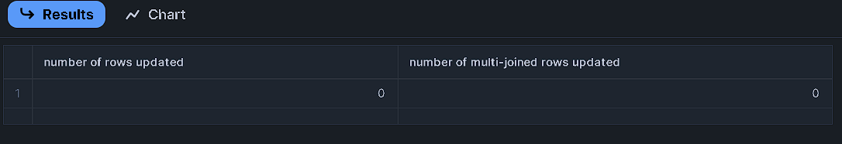**RESULTS:**

//3rd update

update agri

set rainfall_groups='High'

where rainfall >=2800

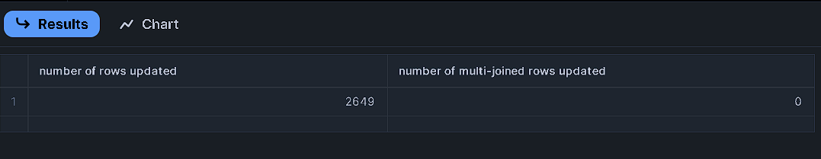**RESULTS:**

select * from agri;

**RESULTS:**

